LEAD GENERATION PROCESS
Tasks
1.Create a simple Google Form to collect leads for a new food delivery app — include fields for name, email, phone number, and favorite cuisine, then share the form link and submit one test entry.
2.Design a landing page mockup (using Canva or Figma) for a Zomato-style offer, highlighting a special deal and a clear call-to-action button for users to sign up with their email.

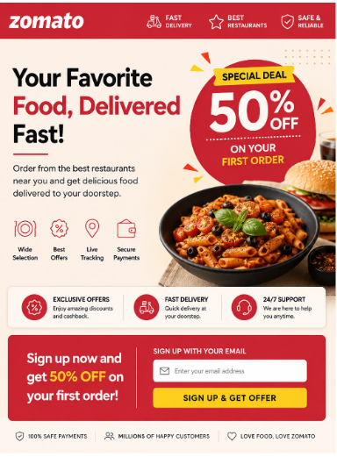

3.List 3 different lead magnets you could use to attract users for a music streaming app like Spotify (for example: free trial, exclusive playlist, discount coupon), and explain in one line how each would collect user info.

Lead Magnet | How it Collects User Information
Free Trial | Users enter their name and email to start a free trial.
Exclusive Playlist | Users provide their email to access special playlists.
Discount Coupon | Users submit their phone number or email to receive a discount coupon.

4.Write a short WhatsApp message template you could use to follow up with a lead who filled out your form for a cricket IPL fantasy league app — include a greeting, mention the app, and a call to action.
=> Answer :

Hii! Thanks for your interest in our IPL Fantasy League App!
Create your team, join exciting contests, and enjoy the IPL experience.
- Sign up now and start playing!
5.Use ChatGPT or any AI writing tool to generate 5 catchy headlines for a Flipkart-style landing page aimed at collecting leads for a new electronics sale.<br><br><em><strong>Hint:</strong> Give the AI a prompt like 'Write 5 headlines to attract users to sign up for early access to a big online electronics sale.'</em>
=> Answer :
5 Catchy Headlines for Electronics Sale :
1. Get Early Access to Our Biggest Electronics Sale!
2. Exclusive Deals Are Coming – Sign Up Now!
3. Be the First to Grab Amazing Electronics Deals!
4. Sign Up Today & Unlock Exclusive Sale Offers!
5. Big Savings Are Coming – Get Early Access Now!

